Processing microtome slides with GIMP and ImageJ

Roman M. Link

October 2019

# Introduction

This is a step-by-step tutorial for the pre-processing and analysis of wood anatomical microtome slides via semi-automatic image classification. The methodology is based on our original tutorials that were using [Photoshop](https://www.youtube.com/watch?v=dQw4w9WgXcQ) and [ImageJ](https://imagej.nih.gov/ij/). Due to the financial pressure posed new subscription-based payment system introduced by Adobe, we felt compelled to switch to a fully open-source solution, which is why our analysis is now using [GIMP](https://www.gimp.org/) for the steps previously done in Photoshop. Both GIMP and ImageJ are very powerful software packages, and a full introduction to their functionalities is beyond the scope of this tutorial. However, note that a list of useful GIMP shortcuts can be found here: (<https://www.gimpusers.com/gimp/hotkeys>).

We are aware that our methods is by no means the perfect way of analyzing wood anatomical slides, and there may be less time consuming ones. However, it ensures comparability to our old datasets obtained by (almost) the same method, and has the advantage of allowing for an accurate assessment of classification errors during all steps of the analysis.

Note that the term CODE in this document is a placeholder that has to be replaced by the unique ID of sample you are working with! In the screenshots in the example, the CODE is CRI_3_010.

# Preparation in GIMP

* Open original image CODE.jpg
* Select the Polygon Lasso tool (GIMP shortcut: *F*) and cut out xylem and pith (double click to finish selection process) 
* Copy selection (*Ctrl + C*)
* Paste selection to new file (*Ctrl + Shift + V*) 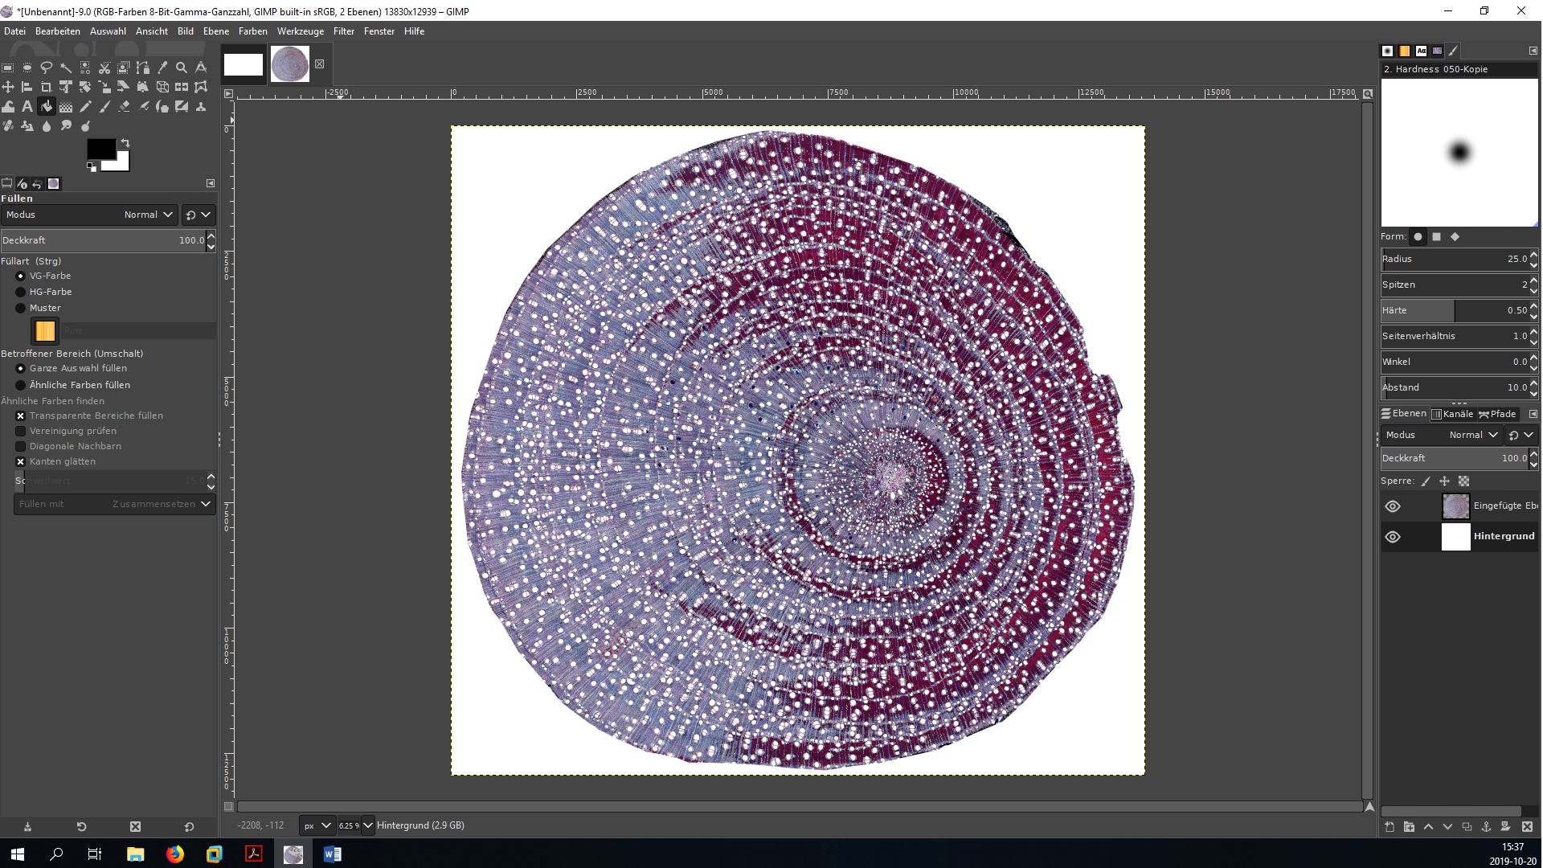
* Close tab with original image (do *not* save changes!) 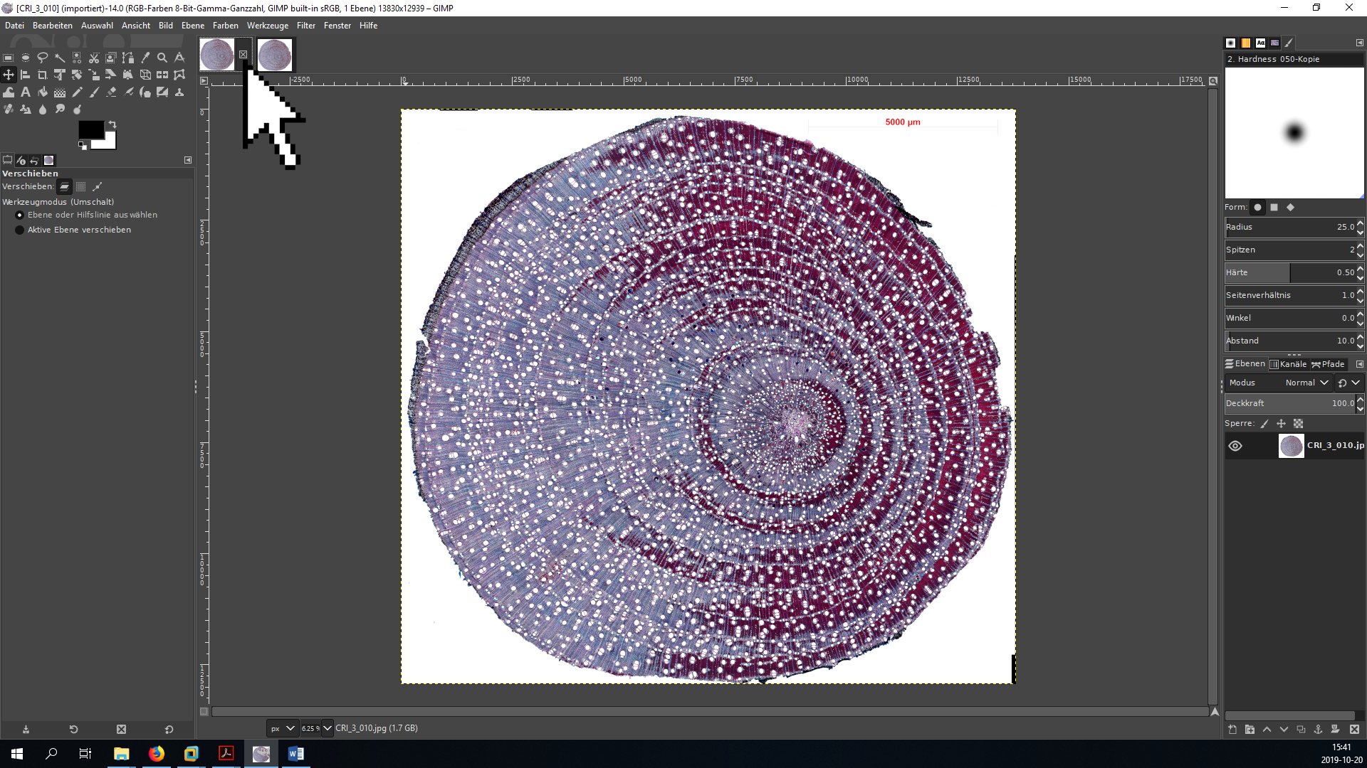
* Zoom in to focus on the pith (*+/-* or *Ctrl + mouse wheel*), select the Polygon Lasso tool (*F*) and cut out the pith 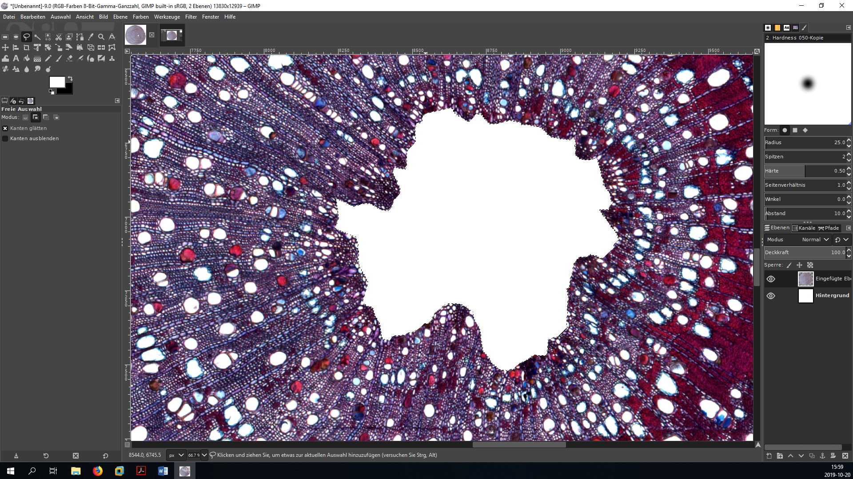
* Export the new picture (full xylem area with cut-out bark and pith) as CODE_GI_01.jpg (export as: *Ctrl + Shift + E*) using the maximal quality setting - the GI in the name codes the GIMP step

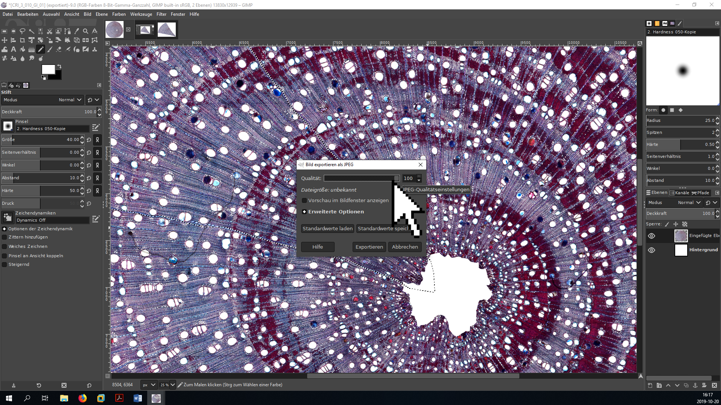

* If the analyzed cross-section is very large, the vessel size is very small compared to the sample area and/or there are areas with severely damaged vessels, it may be advantageous to select only a wedge of the original picture with the Lasso tool (*F*) and insert it to a new file (*Ctrl + Shift + V*) instead of analyzing the entire cross-section to save time. In this case, be careful to select a representative section of the sample (i.e., avoid tension and compression wood). The best is to trace the ray parenchyma to avoid including incomplete vessels. It is usually sufficient to have a subsample of around 300-500 vessels; with 1000+ you are definitely on the safe side.



* if you decide to work with a subsection of the original xylem area, save as CODE_GI_cropped_01.jpg (export as: *Ctrl + Shift + E*) and perform the following steps with this file instead of the original file.
* [optionally] adjust brightness and contrast using color curves (German: **Farben ➜ Kurven**, English: **Colors ➜ Curves**)
  + move the lower point close to the left end of the histogram to make sure the darkest portions of the image are actually black (facilitates thresholding)
  + if necessary, raise part of the upper right portion of the curve above the 1:1 line to increase the brightness of the brightest portion of the image (can be helpful if vessels are partially occluded)
  + This procedure is meant to increase the contrast between vessel lumina and xylem tissue, but take care that the correction does not affect the size of individual vessels (zoom in to the single vessel level to check that no vessels are resized!). This step is only a pre-processing step for the thresholding algorithm in ImageJ, so the separation between light and dark areas does not have to be perfect.



* save the image in GIMP’s .xcf format as CODE_GI.xcf or CODE_GI_cropped.xcf. This file will be used later for the different post-processing steps necessary to improve the initial image classification.
* decompose image into its RGB components (German: **Farben ➜ Komponenten ➜ Zerlegen**, English: **Colors ➜ Components ➜ Decompose**) - this creates a new image that separates the original image into its red, green and blue channel



* hide all layers except the green layer by clicking on the eye symbol in the *Layers* panel, then export (*Ctrl + Shift + E*) the new image as CODE_GI_02.jpg or CODE_GI_cropped_02.jpg (depending on whether or not you work with a cropped subsample)



* close the tab with the black and white image.

# Preliminary analysis in ImageJ

* open ImageJ.
* make sure that the options for analyzing threshold images are correctly set. Go to **Process ➜ Binary ➜ Options** and make sure that the box __Black background is not marked. This is really important because if this box is marked, the particle analysis will not work properly and you will struggle to find out why!



* open the original image with the scale bar (CODE.jpg) with ImageJ (either by the File dialog or by dragging and dropping onto the ImageJ window).
* zoom in (*Strg + mouse wheel*) and move the image with the hand tool (or by holding & clicking while pressing the space bar) until the scale bar fills the entire screen.
* use the **Straight Line** tool to draw a line on top of the scale bar that goes from one endpoint to the other (it can be helpful to first roughly position it and then zoom in more. The endpoints of the **Straight Line** can be repositioned by holding and clicking. The zoom function in ImageJ is atrocious, so do not lose hope when the line disappears - it normally shows up again when you scroll a bit or change the degree of magnification)



* Set the scale to the appropriate value by going to the **Analyze ➜ Set Scale** menu 
* In the corresponding dialog, set the **Known Distance** (the value above the scale bar), the **Unit of length** (normally µm; see scale bar) and - *very important* - mark the box **Global** to make sure that the scale is the same accross all opened documents 
* Open the modified image CODE_GI_02.jpg or CODE_GI_cropped_02.jpg with ImageJ (drag & drop onto ImageJ bar) - if the scale is correctly set, the dimensions of the picture in the unit you specified (likely µm) should be visible in the upper left corner (if not, the dimensions are shown in pixels).
* Transform the grayscale image into a threshold image
  + zoom in until individual vessel lumina are visible.
  + Open the **Threshold** dialog (**Image ➜ Threshold** or *Ctrl + Shift + T*).
  + Choose the options **Default** and **B&W** and mark the box **Dark background**.
  + Move the upper slider to find a threshold value that properly separates vessel lumina from background tissue without shrinking/increasing their size, and with minimal occurrence of “fuzzy edges” (the program calculates an “optimal” value based on criteria which may or may not be useful in your case, so play around – if the contrast was not adjusted, a value between 100 and 130 is usually sensible, but note that especially if you adjusted the color curves or performed a different type of contrast correction the perfect value may be well outside that range)
  + press **Apply** and close the **Threshold** window



* Save this image as CODE_GI_02_TH_01.jpg or CODE_GI_cropped_02_TH_01.jpg
  + do NOT use the Save/Save As shortcut, because it will automatically save in .tiff format
  + instead, use the **File ➜ Save As ➜ Jpeg** dialog



* Now, zoom out and measure the area of the sample
  + use the **Wand** tool to click into the black area around the sample - a portion of the black area will now be [hopefully] selected (highlighted by a barely visible yellow outline) [there are some bugs with the **Wand** tool. If it does not select anything, it sometimes helps if you click into different areas of the image. The lower left seems to work best (don’t even ask…)]
  + measure the size of the selected area using *Ctrl + M* (or **Analyze ➜ Measure** if you prefer point and click)
  + if you work with a full cross-section and removed the pith, do not forget to measure this region!
  + if the surrounding area is separated in several portions, repeat the previous steps for all of them
  + finally, press *Ctrl + A* to select the entire image and measure with *Ctrl + M*



* open the saving dialog by clicking File ➜ Save As in the **Results** window and save as CODE_GI_02_TH_01_Area.xls or CODE_GI_cropped_02_TH_01_Area.xls. The results in that file can be used to calculate the area of the analyzed wood portion by substracting the surrounding black area from the total area of the image.



* Use the **Flood Fill** tool to replace the surrounding black area (and, if applicable, the pith) with a solid white color. 
* Save the image without the black area as CODE_GI_02_TH_02.jpg or CODE_GI_cropped_02_TH_02.jpg
* To prepare for automated vessel detection, open the **Analyze ➜ Set Measurements** dialog and select **Area**, **Shape descriptors**, **Perimeter**, **Fit ellipse** and **Feret’s diameter**



* Open the **Analyze ➜ Analyze Particles** dialog
* You can specify the following conditions each particle has to meet to be included into the analysis
  + **Size** (µm²): range of area for the included vessels (the minimum is normally the more important value becuase it helps to exclude tracheids. For temperate species, a minimum of 100-300 is normally reasonable. The maximum value can usually be left at *Infinity* unless e.g. there are large resin chanels you want to exclude.)
  + **Circularity**: The roundness of the vessels (from 0: not round at all to 1: perfect circles. This can be helpful to exclude brick-shaped parenchyma cells if they are in the same size range as vessels, but may also lead to an exclusion of damaged vessels. Values of 0.3/0.4-1.0 are usually reasonable.)
* before clicking **OK**, make sure to select **Show: Outlines**, and mark **Display Results**, **Clear Results** and **Include Holes**.



* Save the resulting outlines as a .jpg document, specifying the selected **Area** and **Circularity** values in the name (e.g.CODE_GI_02_TH_02_Outlines_300,0.3.jpg or CODE_GI_cropped_02_TH_02_Outlines_300,0.3.jpg) using the File ➜ Save As ➜ Jpeg option in the main menu of ImageJ (not the newly opened **Results** window!). Make sure the right image window is selected when saving.



# Error adjustment in GIMP

* Open the file CODE_GI.xcf (or CODE_GI_cropped.xcf) in GIMP. Drag the files CRI_3_010_GI_02_TH_02.jpg (or CRI_3_010_GI_cropped_02_TH_02.jpg) and CRI_3_010_GI_02_TH_02_Outlines_300, 0.3.jpg (or CRI_3_010_GI_cropped_02_TH_02_Outlines_300, 0.3.jpg) on top of this file (inside the image area) to add them as additional layers

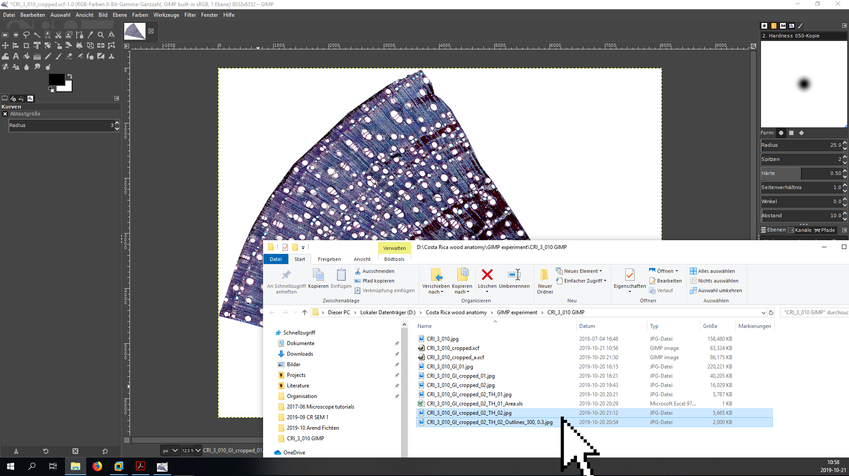

* Click on the foreground color (Vordergrundfarbe) symbol in the left GIMP pane and change the color to green (00ff00 in hexadecimal HTML notation)

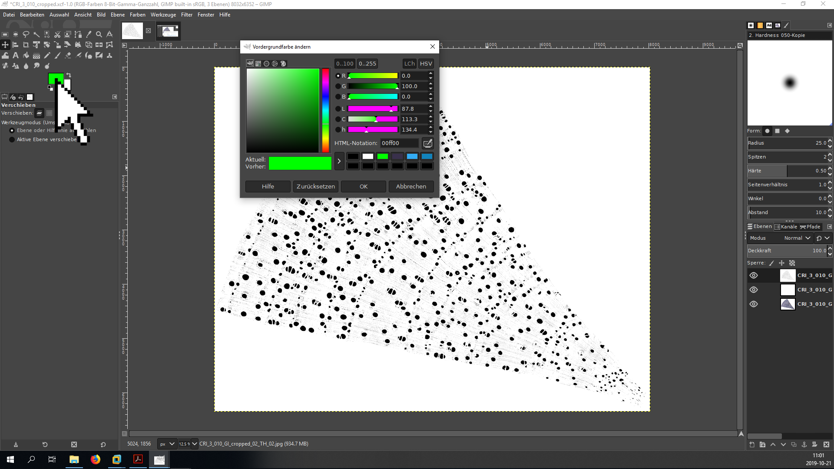

* Right click in the layer pane (bottom right) and open the **New Layer** (**Neue Ebene**) dialog. Set the layer name to “green” and make sure to fill the layer with the foreground color (Füllung: Vordergrundfarbe) to create a brightly green layer

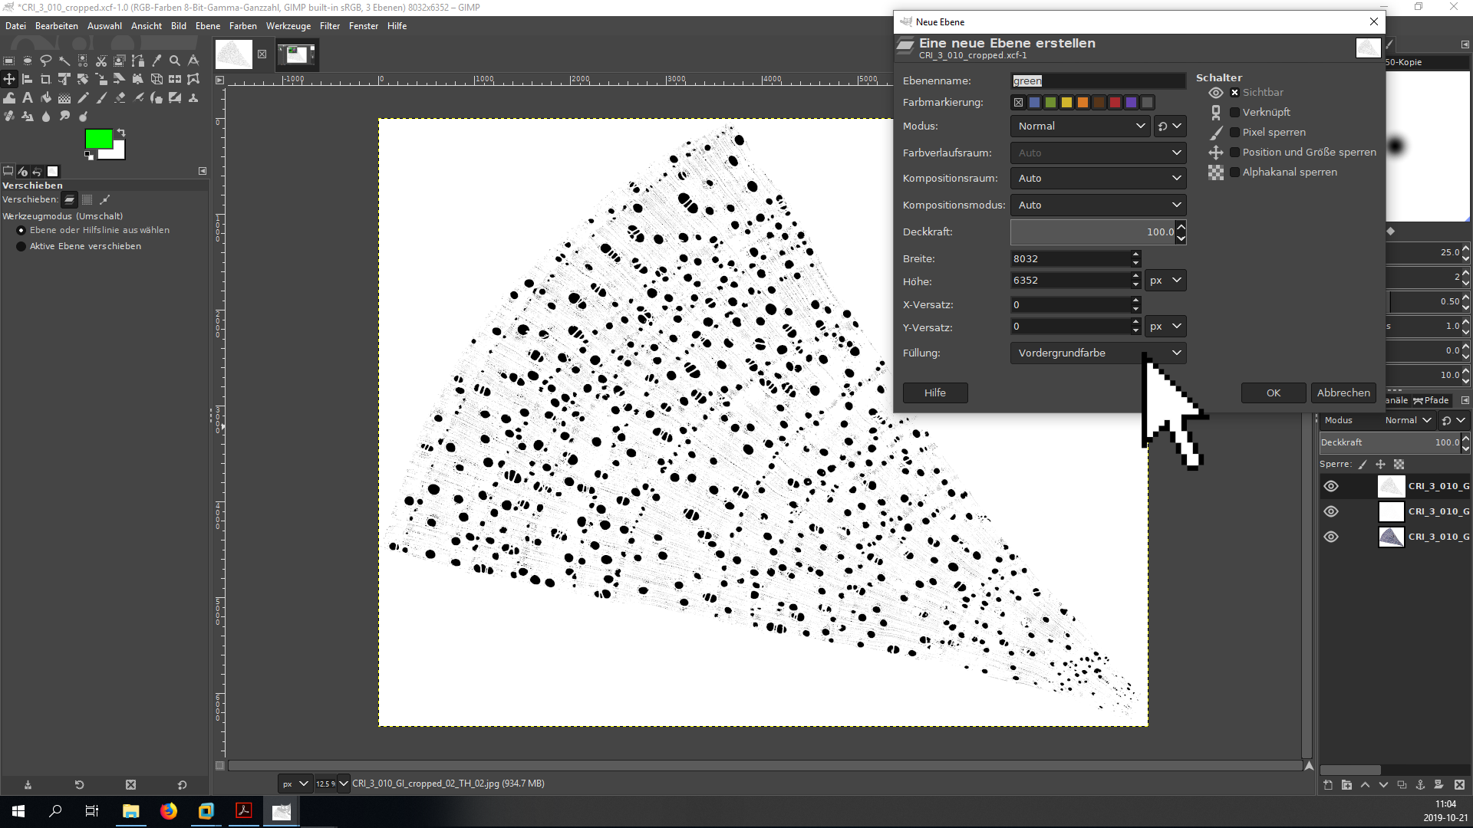

* Double click on the layer names to rename them to make it easier to recognize them and rearrange them in the following order (from top to bottom)
  + Original: **org**
  + Outlines: **out**
  + Green layer: **green**
  + Threshold: **thresh**

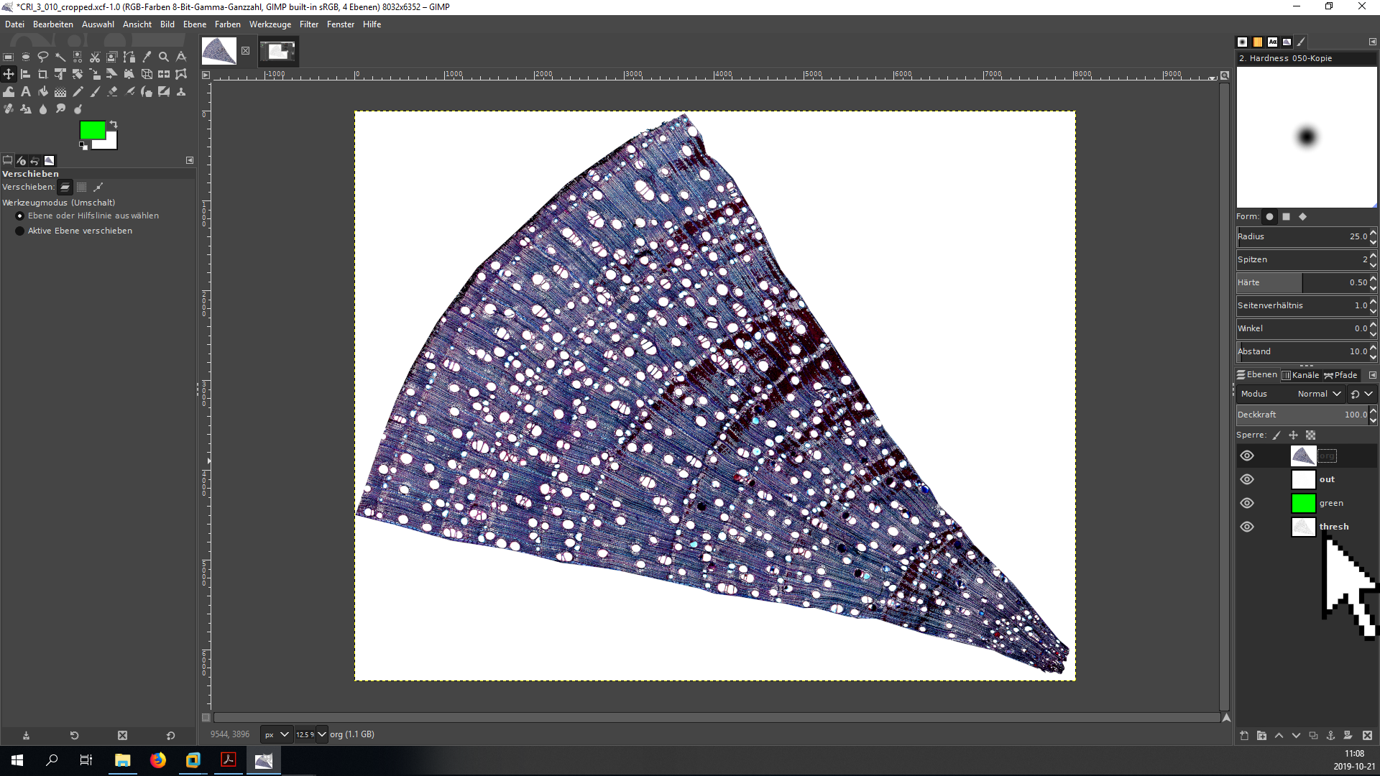

* Right click on the layer **out** and add a alpha channel (**Alphakanal hinzufügen**) to allow for transparency

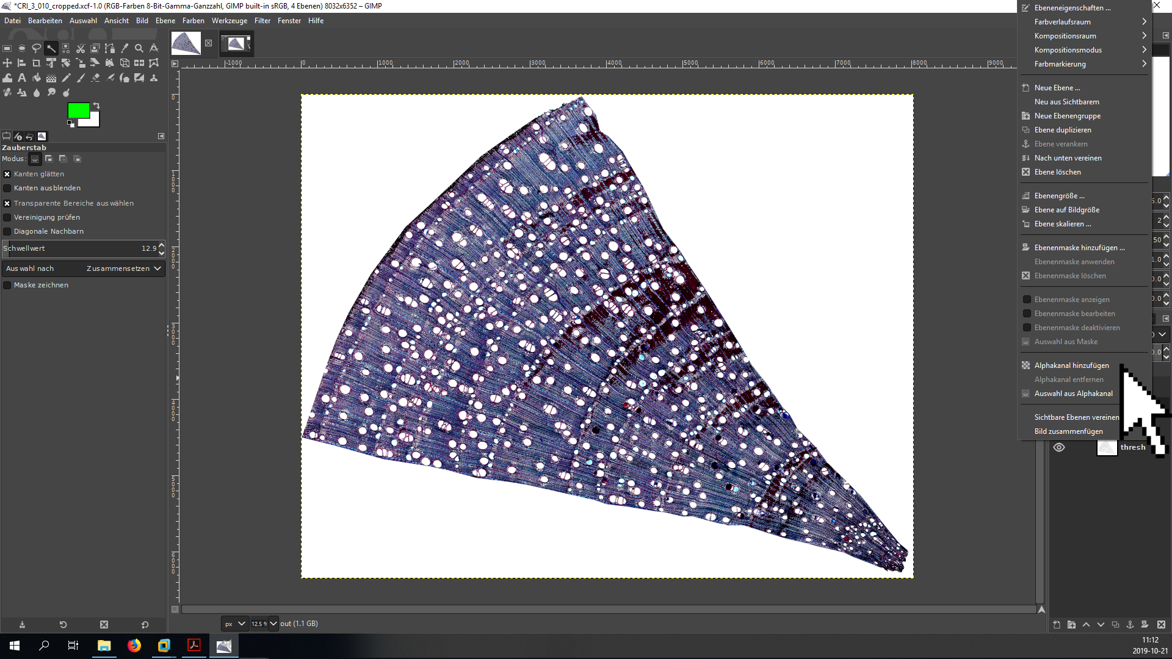

* Click on the eye symbol next to the **org** layer to temporarily render it invisible
* select the **out** layer by clicking on it, then choose the wand tool (click into image window, then press *U*), click into the select the area surrounding the identified conduits and cut it out with *Ctrl + X*. The outcome should look like that:

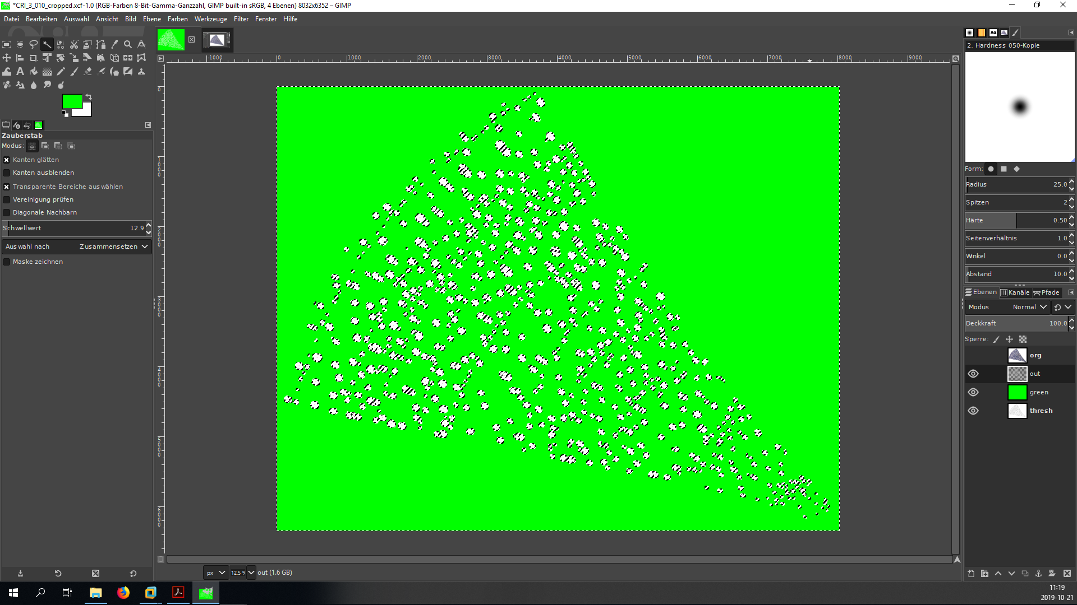

* restore the visibility of **org** and deselect all by pressing *Ctrl + Shift + A*
* use the Layers (Ebenen) panel to change the mode (Modus) and opacity (Deckkraft) of the three layers to the following values:
  + **org** Mode: Darken only (Nur Abdunkeln); opacity: 80%
  + **out** Mode: Difference (Unterschied); opacity: 80-90%
  + **green** Mode: Lighten only (Nur Aufhellen); opacity: 100%
  + **thresh** Mode: Normal, opacity: 100% (leave unchanged)

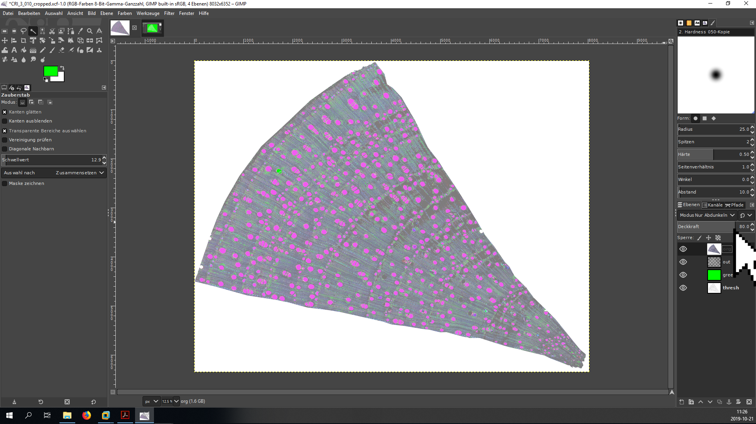

* the image is now ready for editing. Press *Ctrl + S* to save the progress.
* if you set the layer attributes correctly, all areas that are black in the threshold image and that have been identified as vessels by ImageJ’s **Analyze Particles** tool are displayed in red. All areas that are black in the threshold image but were excluded by the **Analyze Particles** tool are displayed in green. The original image is overlayed to enable you to identify how the area looked like in the original image.
* in the following, you will edit the threshold image (layer **thresh**) with the pencil tool (shortcut: *N*) to help the **Analyze Particles** algorithm identify vessels with damaged walls (false negatives: green in the image, but should be red), and to remove elements that were mistakenly identified as vessels, such as resin canels and parenchyma cells (red in the image, but should be green)
* as a first step, check if there are indications that your ImageJ settings should be changed
  + large amount of little tracheids and parenchyma cells included: *minimum size too small*
  + large amount of smaller vessels not included: *minimum size too large*
  + large amount of blocky parenchyma cells included that are of similar size as the vessels: *minimum roundness too small*
  + large amount of vessels not included because of small wall damages: *minimum roundness too large*
  + If consistently, all vessels are too small or too big compared to the original image, consider changing the *threshold* value
* a certain amount of missclassification is unavoidable, but if there are obvious patterns of false negatives/positives it is better to re-run the classification with different parameters and create a new outline image that can be copied into the .xcf file as a new layer out1, out2 etc. (or, in the worst case, set a new threshold) than trying to fix all the errors by hand
* if you are confident that you have found the right ImageJ settings, you can start looking for classification errors that need correction - see the following examples:

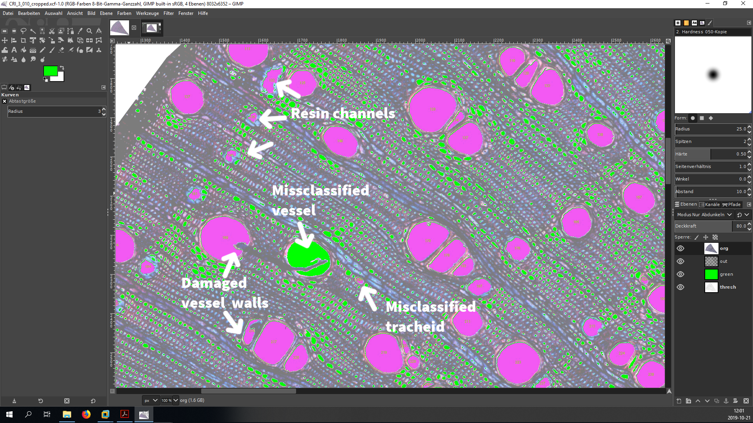

* to manually fix classification errors first make sure that while editing the *foreground/background colors are black and white* (000000 and ffffff), **not green** and that the *threshold layer is selected for editing*
* you can now use the pencil tool (shortcut: *N*) to edit the threshold image
  + complete damaged or missing vessels with black
  + remove miss-classified areas (tracheids, resin channels etc.) with white
  + you can use *X* to switch between foreground/background colors
  + use *Alt + up/down arrow* or *Alt Gr + mouse wheel* to change the pencil size
* After editing, the image with the fixed errors will look somewhat like that: 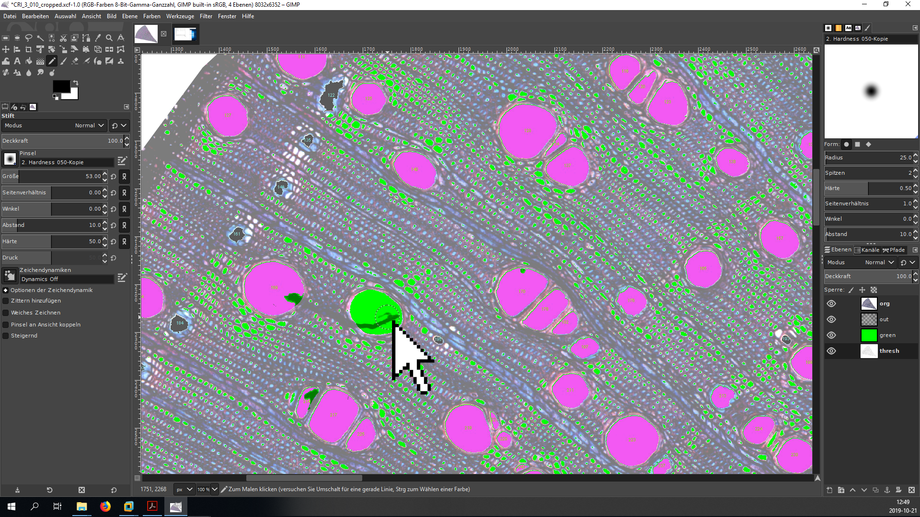
* areas that were (erroneously) classified as vessels that now are removed from the threshold image are **black**
* new additions to the threshold image apear as **green**
* anything that gets removed from the threshold image and was not classified as vessels before is displayed in **white** (e.g. tracheids - if they are to small to get classified, it does not matter if you leave or remove them since they do not affect the results)
* do not spend too much time editing out even the tiniest flaws. Vessel conductivity scales with the 4th power of vessel diameter, so a vessel with 50% of the diameter of another vessel only has 6.25% of its conductivity. For that reason, direct your focus on bigger vessels.
* when you finished editing, save the .xcf file (*Strg + S*).
* now select the threshold layer and press *Ctrl + A*, *Ctrl + C* and then *Ctrl + Shift + V* to mark and copy the entire area of the image and paste it into a new image.
* press *Ctrl + Shift + E* to export this file as CODE_GI_02_TH_02_edit.jpg (or CODE_GI_cropped_02_TH_02_edit.jpg)

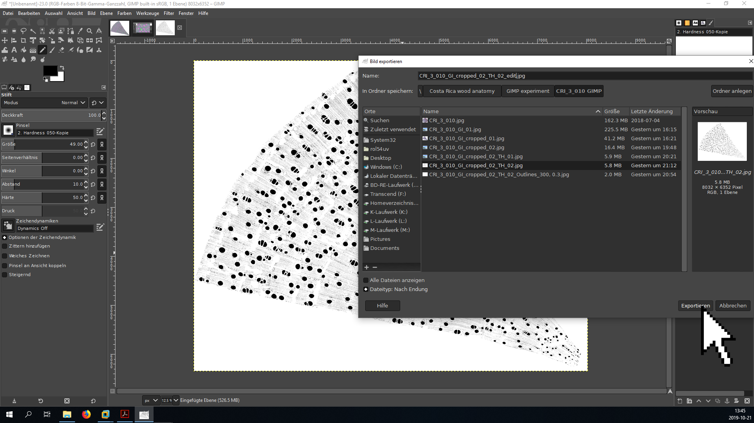

# Final analysis in ImageJ

* open the new threshold file in GIMP (make sure that the scale is still set correctly by looking at the units in the upper left corner - if not, follow the steps in Chapter 2. to reset it)
* add a threshold by pressing *Ctrl + Shift + T* (or **Image ➜ Adjust ➜ Threshold**)
  + the threshold value does not matter since the image is only black and white
  + depending on the geometry of the sample, it may be necessary to uncheck the **Dark Background** box to make sure that the background is white and the vessels black



* repeat the particle analysis step (**Analyze ➜ Analyze Particles**) with the same settings as before



* save the outlines as CODE_GI_02_TH_02_edit_Outlines_300,0.3.jpg or CODE_GI_cropped_02_TH_02_edit_Outlines_300,0.3.jpg (File ➜ Save As in the main window)
* save the results as CODE_GI_02_TH_02_edit_Outlines_300,0.3_Results.xls or CODE_GI_cropped_02_TH_02_edit_Outlines_300,0.3_Results.xls (File ➜ Save as in the Results window)

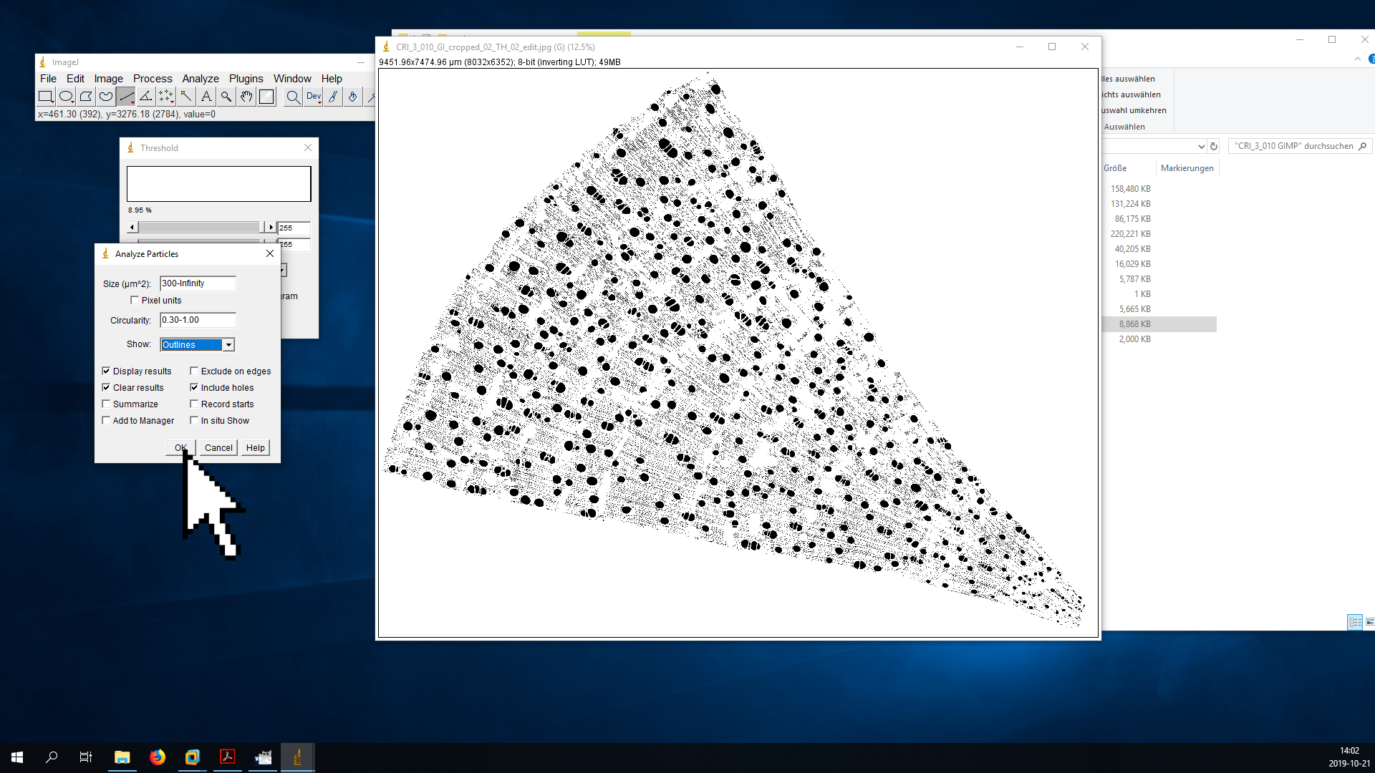

# Final checks in GIMP

* drag the new outline file into the .xcf project
* name the new layer **out1**
* add an alpha channel and cut out the white background (see above)
* put it directly above or below **out** in the layer stack and render **out** invisible
* change the layer attributes to Difference (Unterschied) and an opacity of 80-90%
* check if there still are large amounts of misclassifications
  + if there are, repeat chapters 3-6 (saving the new files as _edit1_, _edit2_ and so on)
  + if not, press *Ctrl + S* and close the file - you are now finished!

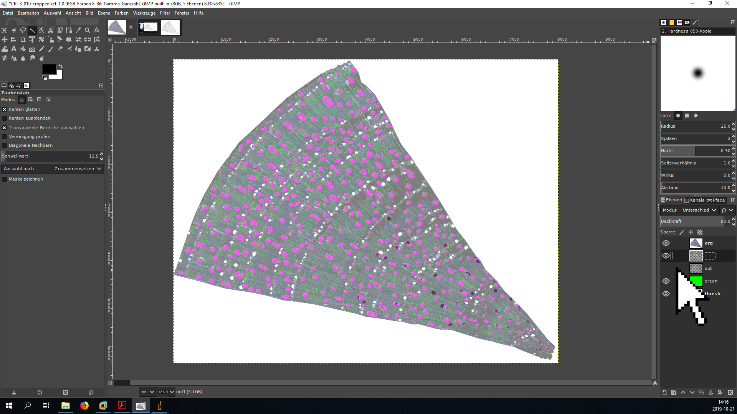

* your project folder should now look somewhat like this (note that often, you will have to try more than one setting for circularity and minimum vessels size, and you will have to do more than one edit, which all show up as additional files in the project folder) 